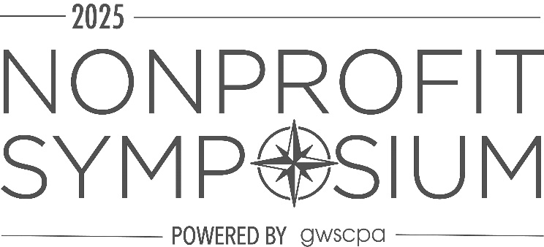
Dear
The Nonprofit Symposium is just one week away, beginning Tuesday, 12/9 at 8:00 AM! As you prepare for an amazing two days of connecting in person with your peers, industry experts and partner resources, here are some important items to be aware of:

SESSION MATERIALS and EVENT APP:
There will only be public wireless available onsite, so we strongly encourage you to download speaker materials and the event app in advance.

To review and print out currently available session materials, visit: https://www.dropbox.com/scl/fo/pnf82dzbj4z4osg8quj0c/AC4457B3kU_7aPbFJZUvfkw?rlkey=y80fl84fpt52rb6zfuue9fbf5&st=u6x5lexo&dl=0 As always, a few of our speakers are continuing to add to their presentations, to ensure they are as up to date as possible and we’ll post once available.

To download the event app: Find “Event app by EventMobi” in your preferred app store and download the app. Once downloaded, search for event: “GWSCPA2025”
Enter the email address you used to register for Symposium and ask for a code (there is no password).

It looks like this: 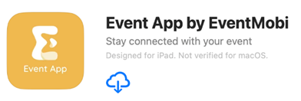

CPE:
This year, during our live program, up to 16 total hours of CPE are available. CPE will be tracked using QR codes. You scan in at start of session, but do not need to scan out. An electronic evaluation will be sent after the event, please fill that out. Certificates will be sent out a few days after the conference, once we have reconciled check-in data.

SCHEDULE:
Registration is located on the 1st floor of the SOUTH building in the Grand Lobby – closest to the main entrance (where taxis drop off). To see a full schedule of events, please visit https://nonprofitsymposium.org/ or www.gwscpa.org .

On Tuesday, Dec. 9, check-in will open at 7:30 AM, with sessions beginning at 8:00 AM. Make plans to stay later on Tuesday: the Networking Reception begins immediately following the end of the sessions at 5:35 PM. Be sure to make use of this exciting time to network with colleagues and peers!

We will continue educational sessions on Wednesday, Dec. 10 with a full day of concurrent breakout sessions from 8:00AM-5:20 PM. Each day will feature a 90 minute networking lunch period where we invite you to mix and mingle with sponsors and attendees. Please sure to check out all the exciting sponsor booths and get to know those who support the local nonprofit community. You can customize a genuine leather tag for yourself or as a gift (Capital One Bank) update your profile with a headshot station (Truist Bank) and find other great incentives and ideas at their booths and at our sponsor silent auction benefitting our Foundation!
CONVENTION CENTER INFO:
The DC Convention Center is located at 801 Allen Y. Lew Place, NW. The Symposium is held in the SOUTH building. (The doors are directly across the street from the Apple store.). If you are coming from the Metro, entrance into the SOUTH building is located on L Street (between 7th & 9th St, NW), and then you will walk all the way through that building to find our registration area in the Grand Lobby. The most convenient Metro stop is the Metro Green/Yellow Line (Mt Vernon Square / 7th St –Convention Center Station).

The building does not have public parking, but there are a number of lots nearby.
Locations can be found at the website here: https://eventsdc.com/venue/walter-e-washington-convention-center/getting-there

ATTIRE:
Dress for the event is business casual. A complimentary coat check will be available.

SPECIAL NEEDS?
If you have any dietary or mobility issues, please let our staff know. Email Ashley Walton ASAP at: awalton@gwscpa.org, and we will do our best to assist and accommodate you. There will be a Mother’s Room available for nursing mothers.

WEATHER AND CANCELLATION POLICY:
The Symposium will only be cancelled due to a catastrophic event, and will proceed as scheduled during inclement weather unless public transportation has been suspended and/or the venue forces cancellation. Check the GWSCPA and Symposium websites for updates should there be inclement weather.

HOLIDAY TOY DRIVE:
The GWSCPA Women’s Leadership Committee is proud to partner with the Latin American Youth Center (LAYC) this membership year to support their incredible work empowering youth across our region. Symposium attendees are invited to bring new, unwrapped toys to help brighten the holidays for the young people LAYC serves. You can see their suggested items at https://www.gwscpa.org/layc.

For any questions or concerns, please contact us at 202-347-3050 or symposium@gwscpa.org .

We look forward to seeing you soon!

GWSCPA Staff

